

UNIVERSITY OF OXFORD

Geography Admissions Test (GAT)

Specimen Paper

You have 1 hour and 45 minutes to complete the test

There are three parts to this test: A, B and C. You must complete all parts.

Part A: Critical thinking
There are two sub-sections to this part of the test. Each sub-section requires you to read a passage and then answer some multiple-choice questions.
You should answer all ten questions in Part A. Each question has one correct answer and is worth one mark.
Allowed time: 30 minutes

Part B: Problem solving
This section has two sub-sections each requiring you to look at some information and answer some multiple-choice questions. Answer all ten questions in Part B. Each question has one correct answer and is worth one mark.
Allowed time: 30 minutes

Part C: Essay
This section requires you to read the passage of text provided and answer the essay question. The essay is worth 15 marks.
Allowed time: 45 minutes

Part A - Critical thinking: Answer all questions in this section

Sub-section (i):
Read the following article from Nature magazine and answer the following questions:

Deadly Afghanistan quake challenges scientists trying to study it
Researchers are relying on limited seismic and satellite information in their efforts to understand the event.
Two weeks after a deadly earthquake hit central-eastern Afghanistan, researchers are still trying to pin down important details about the event, which could help them to assess the risk of future tremors in the region.
The magnitude-5.9 earthquake struck at 1.24 a.m. local time on 22 June near the city of Khōst, which is close to the Pakistan border. The quake and its aftershocks have killed more than 1,000 people and destroyed thousands of homes. But the region has few seismic-monitoring stations, and security concerns and access issues have kept researchers away.
“If this earthquake had happened in Europe, we would have gone there immediately — the day of the earthquake,” says Sofia-Katerina Kufner, a geoscientist at the Karlsruhe Institute of Technology in Germany. “Speed is so important.” Kufner and her colleagues would have used mobile seismic stations to study the aftershocks and identify precise details about the location of the event.
But with sparse seismic data and limited ground observations, researchers are relying more on images taken from space to study the Afghanistan quake and work out where the next one could strike. “We do what we can with remote data, but the results will be far less precise,” says Kufner, who plans to use the satellite information.
Researchers say the devastation is unusual for a magnitude-5.9 earthquake. It was probably caused by the large number of vulnerable buildings in the area, along with the quake’s shallow depth, which is estimated at less than 10 kilometres. This resulted in intense shaking close to Earth’s surface. The timing of the tremors — at night, when many people were asleep in their homes — also contributed to the huge death toll. “5.9 is just a tiny event and it should not kill people,” says Rebecca Bendick, a geophysicist at the University of Montana in Missoula. “If the infrastructure were better, people wouldn’t have died. If the earthquake were deeper, people wouldn’t have died. But that combination of the two was deadly.”

Unmapped area
With few seismic stations in the region, estimates of where the earthquake started underground are less precise. The closest seismic station is in Kabul, some 160 kilometres away, followed by one 350 kilometres away near Islamabad, Pakistan, and the rest are all more than 500 kilometres distant.
Paul Earle, a seismologist who manages the US Geological Survey’s National Earthquake Information Center (NEIC) in Golden, Colorado, says the centre’s estimate of the hypocentre falls within a 15 kilometre area. If the earthquake had happened in California, where there are some 950 operating stations, it would be within 1–2 kilometres. Accurate location data help emergency services to understand the affected area more quickly, he says.
The seismic data that are available suggest that the earthquake was the result of two sides of a fault grating against each other in a horizontal ‘strike-slip’ movement. But it is not clear from those data how and in which direction the rupture propagated — information that would help to identify areas that are now at increased risk of tremors.
One problem is that the earthquake hit in a poorly understood tectonic area, at the boundary between the Indian and Eurasian plates. This region has so many sub-faults and small, unmapped fault traces that it is difficult to identify the exact fault line, says Kufner.
It could take months to get detailed geological reports from the ground, such as evidence of changes to Earth’s surface caused by the earthquake, and these could be washed away by heavy rains, says György Hetényi, a geophysicist at the University of Lausanne in Switzerland.

Limited resources
When the Taliban seized power in Afghanistan in August 2021, the international community responded by suspending funding to the country, including for research. The lack of funding, subsequent exodus of Afghan researchers and limited capacity of those still in the country has further hampered efforts to study the earthquake, say scientists.
Najibullah Kakar, a geohazards scientist at the GFZ German Research Centre for Geosciences in Potsdam, says his colleagues in Kabul are trying to get another seismic station back up and running in the city, but cannot access funds to fix damaged equipment. A temporary network of sensors designed to measure tectonic motion that Kakar and Bendick helped to set up in the country’s northeast in 2016 has also been destroyed and offline since 2021. Kakar hopes the international scientific community will find a way to help “keep the work alive”.
Without ground observations, Bendick thinks researchers will struggle to learn much about the earthquake from satellite data, because it’s not useful for deciphering low-magnitude tremors. “No one will really be able to work on that earthquake, because of the security and access issues,” says Bendick.
But others say that satellite images have already helped to clarify details about the quake. Radar data released last week from instruments aboard several satellites suggest that the rupture propagated from the epicentre in a south-southwest direction, and that it caused a few dozen centimetres of deformation on Earth’s surface, pointing to a very shallow earthquake, says Hetényi.
Nature 607, 433 (2022) doi: https://doi.org/10.1038/d41586-022-01858-x
- Which one of the following statements is supported only by the information available in the article?

  - Pakistan is poorer than most European countries.
  - Earthquakes are more difficult to predict than volcanic eruptions.
  - Satellite observations are also useful for ecological research.
  - Earthquakes of this magnitude are not as destructive in places like Tokyo, where there are earthquake-resistant buildings.
  - The shallow depth of this earthquake was an important factor contributing to the damage caused.

- Which one of the following statements best summarises the article’s main conclusion?

  - Military attacks on infrastructure have hampered earthquake relief efforts.
  - Remote sensing data is now so advanced that it tells disaster relief responders more than field observations do.
  - Greater understanding of earthquake risk requires more accessible field monitoring.
  - US technology should be deployed to Afghanistan.
  - If the earthquake had occurred in the US or Europe, fewer people would have died.

- Which one of the following assumptions does the article’s conclusion depend upon most strongly?

  - Knowing the location of an earthquake helps with disaster response.
  - The more that is known about the locations of geological faults, the easier it is to predict earthquakes.
  - Information on earthquake location can be used effectively by local agencies to coordinate civil response.
  - Afghanistan is poorly equipped to deal with natural hazards.
  - Without information, hazard-prone communities cannot manage their risks.

- Which one of the following statements best illustrates the principle which underpins the article’s argument?

  - Weather prediction would be improved with more observations.
  - Volcanoes kill more poor people than landslides.
  - Food and water shortages are more likely in areas affected by war.
  - Flood risk management involves many stakeholders, so is always difficult.
  - Earthquakes cannot be predicted.

- Which one of the following statements, if true, most weakens the article’s main argument?

  - Using satellite observation for earthquake research is more expensive than other research methods.
  - Other locations which are prone to earthquakes have been heavily researched using field observations, but this has not resulted in better understanding of earthquake risk in those areas.
  - Earthquakes in the US and Europe can also cause a lot of damage.
  - Satellite observations can clarify details about an earthquake without the need for researchers to physically visit the location.
  - Most earthquakes are high-magnitude tremors and so are observable by satellite.

Sub-section (ii):

Read the following article from The Conversation and answer the following questions:

Maps show – and hide – key information about Ukraine war

“All maps are lies,” my colleague, geographer David Salisbury, says.
He’s right. All maps are inherently incomplete, focusing on certain subjects and areas to the exclusion of others. These are crucial aspects of rhetoric, the field I study. Every map distorts the world, whether it’s of a local area or the whole Earth. No map can do otherwise, except a map exactly as large as the territory it depicts – though as the author Jorge Luis Borges famously pointed out, that map would be useless.
But maps’ lies can be productive. Maps can simplify the world and make it more easily comprehensible.
Geographers often speak in terms of what they call the “silences” of maps – what’s missing and unseen, hidden in the margins. Those silences are just as meaningful as what’s on the page. It’s important to ask what has been left out.
That’s certainly true when looking at maps depicting aspects of Russia’s war on Ukraine. News organizations around the world have published many maps of the crisis, but their standard views are not the only way maps can help people understand what is happening in Ukraine.

Surrounded
Most typical news maps show Ukraine as an encircled and embattled nation.
Even without other markings, Ukraine appears small, with Russia looming over it from the north and east. Once annotated with arrows showing the general directions of invasion forces, icons showing specific attacks, and dots highlighting Ukrainian nuclear plants and other strategic targets, these maps can signal an inevitability of Russian advancement. They also tend to exaggerate the idea that it’s a coordinated, controlled assault – when, of course, war is famously chaotic.
These maps don’t show the topography of Ukraine or its road network. They mostly show political borders crossed by lines and arrows representing the movements of Russian soldiers, part of the second-most-powerful military in the world.

Ukraine appears on these maps as a puzzle piece amid the rest of the puzzle of Europe, a shape at the center surrounded by small pieces of surrounding nations. It could be an open container waiting to be filled with chaos, or one that is spilling chaos into the rest of Europe.
These maps do not often show the location or strength of Ukrainian resistance. Nor do they depict the complex flow of refugees fleeing the fighting, which is usually either simplified or left out altogether.
The everyday experiences of civilians on the ground in this war remain elusive in these maps. The maps appear to be authoritative and absolute, but the reality is much messier and uncertain.
This is not a critique of mapmakers who are depicting the war on Ukraine. Their work has often been productive and insightful, helpfully simplifying an incredibly complicated situation into one or two clear statements. They use a familiar mapping style, one that came into its own during World War II. Maps in the media were portrayed as documents that could help everyday citizens connect with the war. President Franklin Roosevelt even asked Americans to “look at your map” as he spoke over the radio about fighting in Europe and the Pacific.
The news maps of that time projected the anxiety and vulnerability of strategic areas for the United States and their allies. They signalled directly that U.S. involvement was necessary. As the Cold War emerged, and maps shifted their anxiety toward the Soviet Union, the simplicity and directness of many maps sought to sound the alarm about Soviet encroachment into the heart of Europe, and communist threats in Asia and Africa.
The maps of the war in Ukraine are often more sophisticated and sometimes interactive, but they still carry the alarm of inevitable Russian advancement and project the familiar concept of the battle between East and West.

Multiple perspectives
There are, of course, other ways to map this war. Some global news outlets are presenting a series of maps, rather than just one. Al Jazeera, Reuters’ graphics division and the Financial Times offer prime examples of putting a series of maps into conversation with one another and creating a kind of narrative of the war – for example, putting maps of NATO members alongside maps of oil and gas resources, while still portraying the essential military advancements.

Specific approaches
Groups other than news outlets are showing additional ways to use maps. The Centre for Information Resilience, a U.K. nonprofit seeking to expose human rights abuses, is using crowdsourcing technologies to populate maps of Russia’s war on Ukraine with civilian casualties, incidents of gunfire and explosions, and evidence of damage to infrastructure. That method gives readers themselves a chance to choose where and what they want to see of the invasion.
The Live Universal Awareness Map is an independent journalism site that draws on news stories and social media from all over the world and connects them to an interactive online map. Its Ukraine map shows where reported incidents occur, with colored icons showing who is reportedly involved at each location. The icons represent many types of events, including speeches and rallies, refugees and hostage situations, and even computer hacking.
These alternatives to the more standard news maps of war also have their benefits and drawbacks. Maps like the Live Universal Awareness Map rely on crowdsourced data that might be tricky to verify. But more importantly, they point out that mapmaking is a political and cultural effort that creates compelling and useful stories – even if not necessarily unvarnished truth. A critical eye and a sense of context can go a long way toward keeping the lies of maps productive.

- Which one of the following statements best summarises the author’s main criticism of the way in which Ukraine is presented in the maps of news organisations?

  - Key natural features, such as waterways, mountains, lakes, and forests, which would make Russian advancement difficult, are missing.
  - Ukraine is distorted and is too small compared to Russia.
  - The static maps fail to keep up with a dynamic and changing battlefield reality.
  - The invasion of Ukraine appears to be simpler than in reality, and almost inevitable, as the complexities of the war and the strength of local resistance are not visible.
  - The war is presented as too easy for Ukraine, which is doing incredibly well to repel the second-most-powerful military in the world.

- Which one of the following statements best reflects the main argument of the author?

  - We need to better represent the spatial dimensions of warfare using maps.
  - When presenting geographic information, the author makes choices on what information to include/exclude, which we should bear in mind when analysing sources of information.
  - Maps are an inherently unreliable source of geographic information.
  - Whenever we study a source of information we must acknowledge the political biases of the author.
  - News organisations should use better mapping techniques to more accurately represent the invasion of Ukraine.

- Which one of the following statements best summarises the article’s main conclusion?

  - Ukraine is likely to lose the war against Russia.
  - There are many different ways to present information in both human and physical geography.
  - Maps often miss out information, but studying what has been left out is often as interesting or productive as looking at what has been included.
  - A map the size of the territory it depicts would be useless.
  - Maps produced by the media have failed to accurately represent the reality of the war in Ukraine.

- Which one of the following statements best illustrates the principle which underpins the article’s core argument?
  - Using numerical data is a better way to study warzones as it is not affected by political biases.
  - Geographical research is now easier thanks to digital mapping techniques, which can be especially useful for studying inaccessible research sites.
  - Newspaper reports often miss out information and are subject to political and cultural influences, but this does not mean they are useless, as identifying the missing information can be just as productive as studying an accurate report.
  - Geographers have a responsibility to criticise the media when they report events inaccurately.
  - Interviews are a useful and productive method of research as people sometimes lie, which can illustrate their biases or knowledge gaps.

- Which one of the following assumptions does the article’s conclusion depend upon most strongly?
  - Every kind of map has excluded some form of relevant information.
  - Maps of war are a poor way to summarise complex information for public audiences.
  - Russia is the aggressor in the war in Ukraine.
  - Accurately and completely depicting large areas is easier now than in the past.
  - Information missing from maps is a result of conscious decisions by mapmakers rather than accidental oversight or a lack of data.

[END OF PART A]

Part B - Problem solving: Answer all questions in this section

Sub-section (i):
Study the graph below which shows decadal temperature between 1850 and 2020.
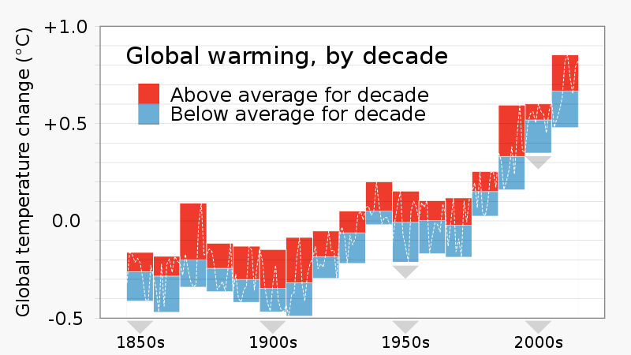

- Which decades saw the greatest range in temperatures?

  - 1870s and 1990s
  - 1950s and 1980s
  - 1990s and 1850s
  - 1940s and 1950s

- Which of the following graphs most closely approximates the rate of change of decadal average temperature?

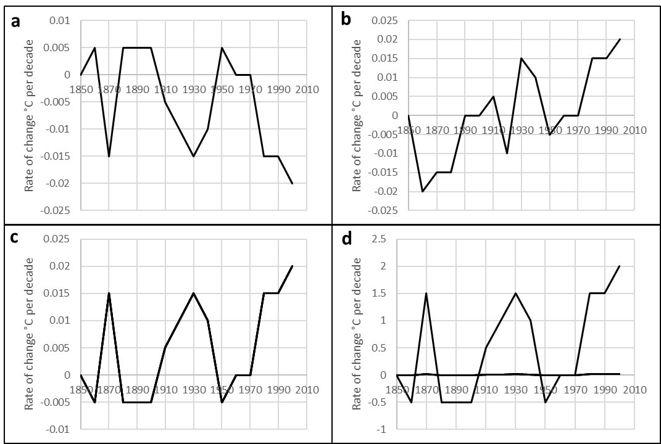

- Which period saw the start of the longest consistent run of increases in mean decadal temperature?

- 1870s
- 1950s
- 1970s
- 1940s

- In which decade of the 20th century was the 1870s temperature record broken?

- 1870s
- 1940s
- 2010s
- 1990s
- 1980s

- Using the information available on the graph, which statement most accurately describes the average change in mean temperature between 1850 and 2010?

- 0.5 K per decade
- one degree per century
- 1.667 °C per year
- 1.2 K yr⁻¹
- 0.2 °C per decade

Sub-section (ii):
Study the graph below which shows the share of global exports by income level of the trade partners.
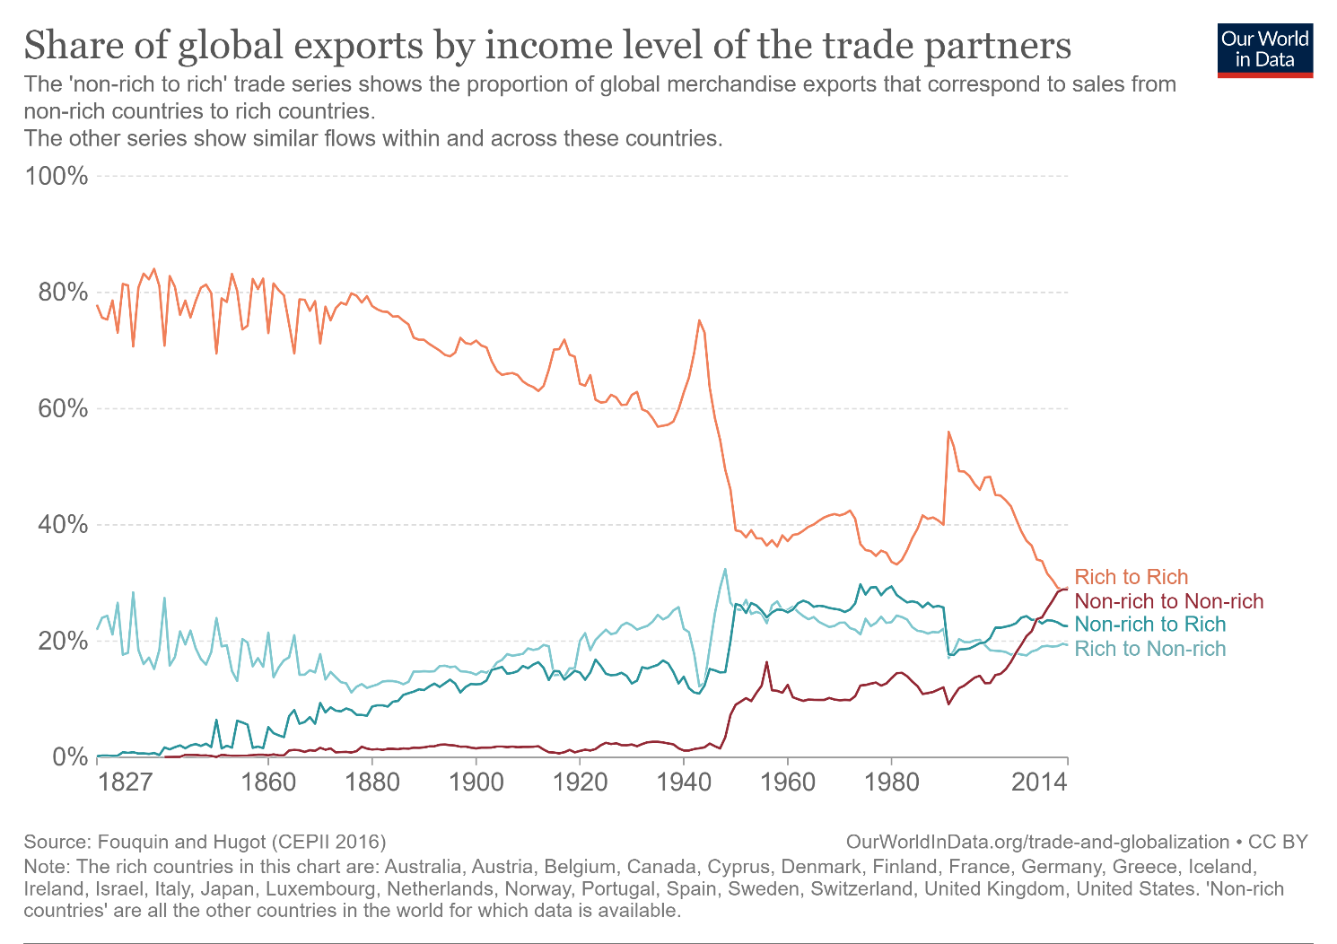
- In which year did Rich to Rich trade peak?
  - 1943
  - 1838
  - 1860
  - 1991
  - 2014

- Which one of the following statements is not true?
- Overall, the share of Rich to Non-rich trade from 1827 to 2014 is increased slightly.
- The share of Rich to Rich trade has decreased overall from 1827 to 2014, but this rate of change was not constant across the time period.
- In 2014, the share of Non-rich to Non-rich trade became approximately equal to Rich to Rich trade.
- The largest year-on-year increase in the share of Rich to Rich trade was from 1990 to 1991.
- The share of Non-rich to Non-rich trade increased at a fairly steady rate from 2000 to 2014.

- Which one of the following statements, if true, most strongly supports a trend that is observable in this data?

- Decreasing costs for freight shipping has led to an overall increase in global exports.
- The majority of Rich to Rich trade is between the United States of America and the European Union.
- Since the early 1990s, the growth of China’s trade with other Non-rich countries has led to the share of Non-rich to Non-rich trade increasing to match that of Rich to Rich trade.
- The Covid-19 pandemic will have resulted in increased Rich to Non-rich trade through the supply of vaccines and PPE.
- The British Empire was responsible for the majority of Rich to Non-rich trade before 1945.

- Which of the following statements best summarises a trend in the data?

- Global exports have decreased overall from 1827 to 2014.
- While the share of Rich to Rich trade has decreased over the last century, the share of Non-rich to Rich trade has stayed relatively constant.
- The end of the First World War in 1918 saw a huge increase in the share of Rich to Rich trade as peace resulted in easier trade. However, this share declined steadily over the rest of the 20th Century.
- As the share of Rich to Rich trade declined from 1827 to 2014, the shares of Rich to Non-rich, Non-rich to Rich, and Non-rich to Non-rich all increased.
- Rich to Rich trade accounted for the majority of global exports until World War Two in the 1940s. However, by 2014, trade between non-rich countries accounted for as much of the global exports as rich to rich trade.

- Which of the following statements best reflects a limitation of this chart?

- The scale is not logarithmic, which means that exponential change is harder to see.
- Not every year is marked, meaning that it is difficult to read precise data points.
- The categorisation of ‘Rich’ countries is potentially misleading as it does not include more recently-wealthy economies such as Saudi Arabia or the large economy of China.
- The chart does not show the absolute value of global exports by trading partners.
- There may be some Rich countries for which there is no data available.

[END OF PART B]

Part C – Timed essay: read the passage and answer the essay question

Study the passage of text, which is an extract from a speech made by UN Secretary-General António Guterres at the COP26 World Leaders Summit in November 2021. Then write an essay in response to the following question:

What can we learn from this speech about the United Nations stance towards tackling the problem of climate change?

Your answer should be based primarily on your response to material in the passage; no additional credit will be given for reference to material outside the passage.

“The six years since the Paris Climate Agreement have been the six hottest years on record. Our addiction to fossil fuels is pushing humanity to the brink. We face a stark choice: Either we stop it — or it stops us. It’s time to say: enough. Enough of brutalizing biodiversity. Enough of killing ourselves with carbon. Enough of treating nature like a toilet. Enough of burning and drilling and mining our way deeper. We are digging our own graves.
“Our planet is changing before our eyes — from the ocean depths to mountain tops; from melting glaciers to relentless extreme weather events. Sea-level rise is double the rate it was 30 years ago. Oceans are hotter than ever — and getting warmer faster. Parts of the Amazon Rainforest now emit more carbon than they absorb. Recent climate action announcements might give the impression that we are on track to turn things around. This is an illusion.
“The last published report on Nationally Determined Contributions showed that they would still condemn the world to a calamitous 2.7 degree increase. And even if the recent pledges were clear and credible — and there are serious questions about some of them — we are still careening towards climate catastrophe. Even in the best-case scenario, temperatures will rise well above two degrees. So, as we open this much anticipated climate conference, we are still heading for climate disaster. Young people know it. Every country sees it. Small Island Developing States — and other vulnerable ones — live it. For them, failure is not an option. Failure is a death sentence.
“We face a moment of truth. We are fast approaching tipping points that will trigger escalating feedback loops of global heating. But investing in the net zero, climate resilient economy will create feedback loops of its own — virtuous circles of sustainable growth, jobs and opportunity. […] The climate action army — led by young people — is unstoppable. They are larger. They are louder. And, I assure you, they are not going away. I stand with them.
“The science is clear. We know what to do. First, we must keep the goal of 1.5 degrees Celsius alive. This requires greater ambition on mitigation and immediate concrete action to reduce global emissions by 45 per cent by 2030. G20 countries have a particular responsibility as they represent around 80 per cent of emissions. According to the principle of common but differentiated responsibilities in light of national circumstances, developed countries must lead the effort. But emerging economies, too, must go the extra mile, as their contribution is essential for the effective reduction of emissions. We need maximum ambition – from all countries on all fronts – to make Glasgow a success.
[…]
“The sirens are sounding. Our planet is talking to us and telling us something. And so are people everywhere. Climate action tops the list of people’s concerns, across countries, age and gender. We must listen — and we must act — and we must choose wisely. On behalf of this and future generations, I urge you: Choose ambition. Choose solidarity. Choose to safeguard our future and save humanity. And I thank you.”

[END OF TEST]

