SUBMITTING WORK – RESEARCH DEGREES
- Complete a blue receipt

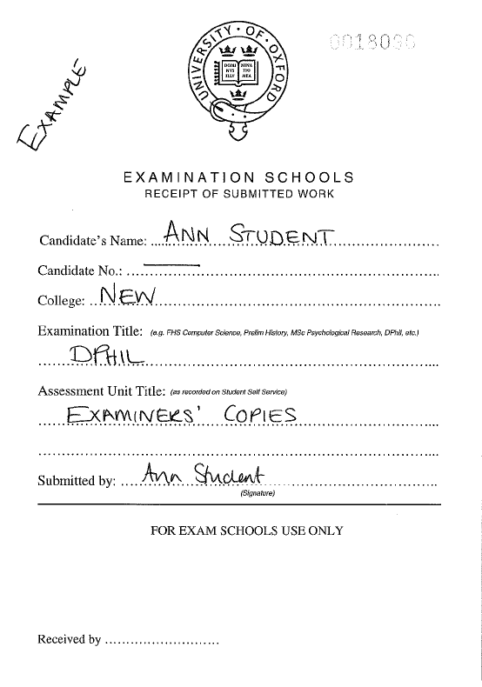
Candidate No:
Not applicable
Assessment Unit Title - Examiners’ copies or Library copy
Examination Title i.e.
DPhil/MSc by research/MPhil in Law

- Envelopes

Please DO NOT write anything on your envelopes!
Please DO NOT seal your envelopes!

- Bodleian Copies

If you are submitting the hardbound copy of your thesis for the Bodleian, you do not need an envelope. You will also require forms GSO3a and GSO26 to accompany the thesis. Please ask at the submissions desk if you need them.

- Hand in your to the Submissions desk.

- Your receipt will be date and time stamped. A yellow copy of the receipt will be given to you for your record.

