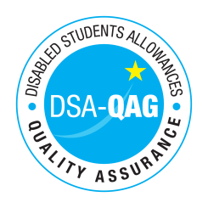
University of Oxford – NMH Rates

Period covered from 01/04/2019

The table below shows NMH rates. The greyed out cells indicate that the NMH provider does not offer these services.

Note: NMH Support Rates shown per hour in the table below.
 | Standard Rate (in-person) |  |  | Distance Learning only (in-person, in-home |  |  | Remote Delivery (e.g. Facetime/Skype or similar) Only
Band 1 Support Assistants | Net | VAT | Total | Net | VAT | Total | Net | VAT | Total
Practical Support Assistant | £15.90 |  | £15.90
Library Support Assistant | £15.90 |  | £15.90
Reader | £15.90 |  | £15.90
Scribe | £15.90 |  | £15.90
Workshop / Laboratory Assistant | £17.90 |  | £17.90
Band 2 Enhanced Support Assistants
Study Assistant | £19.90 |  | £19.90
Examination Support Worker | £17.90 |  | £17.90
Note Taker | £17.90 |  | £17.90
Band 4 Specialist Access and Learning Facilitators
Specialist Mentor – Mental Health | £57.50 |  | £57.50 |  |  |  | £57.50 |  | £57.50
Specialist Mentor – AS | £57.50 |  | £57.50 |  |  |  | £57.50 |  | £57.50
Specialist 1:1 Study Skills Support - SpLD | £58.00 |  | £58.00 |  |  |  | £58.00 |  | £58.00
*Please delete any rows where you do not provide this support role

