IT tools to help you study effectively and efficiently
Free 1 hour session at Banbury Rd
Wednesday 25th October at 5.30pm or
Wednesday 15th November at 5.30pm
A brief introduction to key assistive technology and apps that might help you to work and study more efficiently. Tools for planning and organisation, reading and writing will be included. We will show you free or low-cost tools available for both PCs and Macs and provide information on where and how to source the tools yourself.
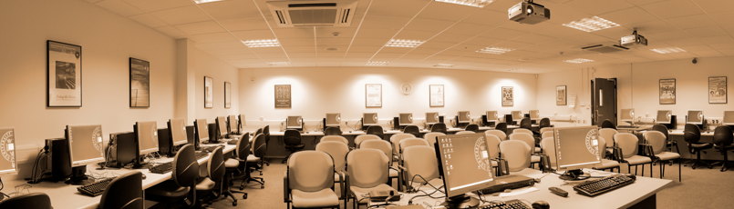
Book a place online through the IT Learning Centre by clicking a date below-
Wednesday 25th October
Wednesday 15th November

