Testing for COVID-19: Early Alert Service – Michaelmas Term Report
Professor David Mant
Outgoing EAS Clinical Director
23 December 2020

Introduction
The Testing for COVID-19: Early Alert Service (EAS) was launched to minimise the impact of students and staff arriving at the beginning of Michaelmas term with COVID-19 infections by acting early to identify and isolate cases within the University. Alongside keeping all members of the collegiate University as safe as possible through easy access to testing, a major objective was to avoid disruption to local health services and to help protect the local Oxford community by minimising the spread of the virus.

Success of the testing service in Michaelmas term
EAS provided RT-PCR testing for SARS-CoV-2 for all staff or students with symptoms of COVID-19 infection. From mid-August when the Service was launched, a total of 5,842 tests were undertaken before the testing centres closed for Christmas. EAS was successful in containing the spread of COVID-19 among staff and students in Michaelmas term. It not only enabled the University to contain a spike that arose within college communities, but also resulted in a low number of staff cases – much lower than in the general population. This includes external positive tests; 41 staff tested PCR positive outside the EAS system, mainly because they were working from home (so sought NHS testing locally) or were participating in the Oxford University Hospitals staff testing programme.

The three key lessons to take away from the EAS experience in Michaelmas term are:
- In a collegiate University, outbreaks can be contained by symptomatic testing alone if there is easy access to immediate testing, results are not delayed, and isolation of index cases and their close contacts is rapid and effective.
- Asymptomatic testing on arrival in Hilary term could reduce seeding and hence the likelihood of a major outbreak.
- The public health measures that have been put in place by the University are effective and will limit the spread of outbreaks (both from students to staff and to the general population), but the end-of-term resurgence of the virus means they will need to be continued this term until those at significant risk have been vaccinated.
However, as I said in my recent blog in the University Bulletin, testing is only a small part of containing COVID-19 infection. Although I’m extremely proud of the team of nurses and students who staffed the two testing pods despite the personal risk, the success of the EAS programme depended on the effectiveness of the action taken when positive SARS-CoV-2 results were reported. It is the students and staff themselves, observing self-isolation rules despite the personal cost (whether index cases or close contacts), who need to take the main credit. Nevertheless, the College and Departmental COVID teams (the ‘SPOCs’) who supported them also deserve recognition and thanks – as well as the EAS Results Liaison Team who supported the SPOCs.

And it bears repeating that the EAS is a tremendous example of NHS–University joint working, as well as of teamwork within the University. I will not name individuals because of the risk of omitting people who played an important role, but the service would not have happened without the NHS staff at the John Radcliffe Hospital microbiology laboratory, the Medical Sciences IT and University Estates teams, and the College and Department SPOCs – and of course both our medical students and a “Dad’s Army” of clinician volunteers.

The epidemic curve
The epidemic curve for the Michaelmas term is shown in Figure 1 below. EAS reported its first SARS-CoV-2 positive case on 13 September. The number of positive cases increased with the arrival of undergraduate students on the weekend of 3/4 October, with a spike the following week (which peaked on 16 October). It took approximately 4 weeks for this spike in cases to be contained to previous levels. The first day with no positive cases reported was 24 November.
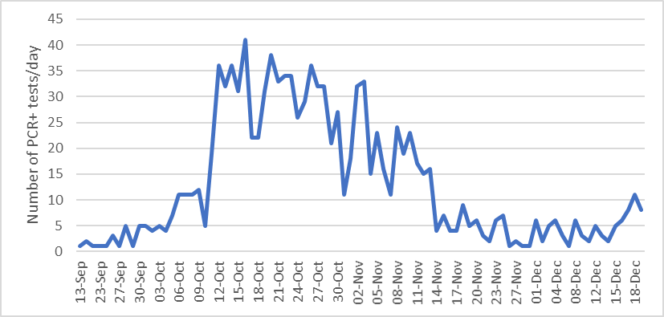
Figure 1: SARS-CoV-2 epidemic curve for Michaelmas Term
The average number of cases from 25 November until the end of the undergraduate student travel window on 9 December remained about 50% higher than it had been in the two weeks before the start of the undergraduate term, but this in part reflects the impact of the government Christmas Travel testing programme; two-fifths (20/50) of the positive PCR tests during this period were confirming positive LFD tests in asymptomatic students.
About 1 in 5 of those tested (1,141/5,842, 19.5%) had a SARS-Cov-2 positive result. The proportion of positive tests each week varied from 1% before term began to a peak of 33% in early November (see Figure 2), mainly reflecting the increasing prevalence of COVID-19 as the cause of upper respiratory symptoms. However, the positivity rate will also reflect changing criteria for symptomatic testing. As the demand for testing increased, we restricted testing to individuals with the cardinal symptoms (fever, cough and loss of taste/smell) to ensure laboratory capacity was not overwhelmed.
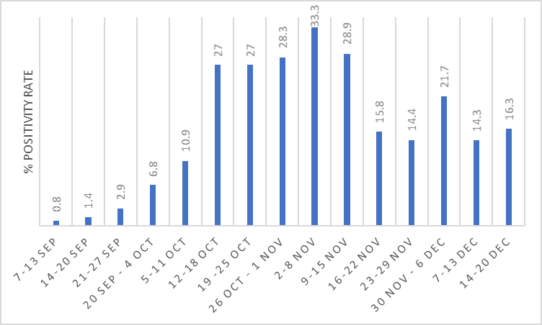
Figure 2: Proportion of RT-PCR tests reported as positive each week

Comparison of infection rates in students and staff
Of the 1,141 individuals who tested positive, the vast majority (1,071, 94%) were students – see Figure 3. Of these 1,071 students, 895 were undergraduates (84%), 171 postgraduates (15%) and 5 visitors. Of the 70 staff, 26 had a College affiliation and 7 lived in College. Overall, 4.4% of all students and 0.5% of all staff in the University had EAS positive tests during the term.

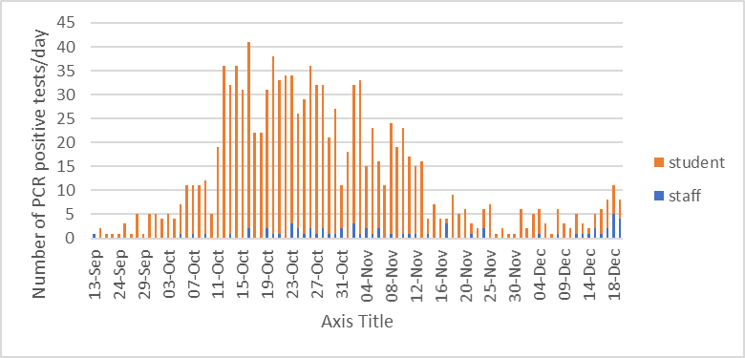
Figure 3: Number of staff and students testing positive for SARS-Cov-2 (EAS RT-PCR testing)
In addition, 42 students and 24 staff reported positive PCR tests done elsewhere (mainly NHS Pillar 1 or 2 tests), so the overall proportion of University members with confirmed COVID-19 infection last term was 4.5% of students and 0.6% of staff. The student numbers are similar to, and staff numbers considerably less than, the age-specific COVID-19 incidence in the local population (proportion of Oxford population testing positive from 29 August to 11 December: age 15–24, 4.2%; age 25–64, 1.6%).

Christmas Lateral Flow testing
The University participated in the government Christmas Travel programme, in which asymptomatic students were offered LFDs (later flow devices) to self-test before travelling home; the few reporting positive LFD tests were offered a confirmatory PCR test. By 22 December, 4,678 students (74% undergraduates, 26% postgraduates) from 42 Colleges had reported the results of Christmas Travel tests. No significant reservoir of residual COVID-19 infection was detected. Overall, 28 students (0.6%) reported positive results. The lateral flow testing picked up two small emerging outbreaks, which, on investigation, were attributed to pre-Christmas social events involving household mixing. A number of students reported COVID-19 symptoms at PCR testing, so it is likely that symptomatic testing would have picked up both outbreaks.

Protection of the Oxford population
A key objective of the EAS service was to protect the whole population of Oxford, not just the University. To this end, in all instances where we supected there was a risk to the general population (e.g. a student reported attending a public venue), we informed PHE/Oxfordshire PH as appropriate. To our knowledge, no outbreaks of infection in the city investigated by Oxfordshire Public Health or Public Health England have been attributed to a University source.
EAS data were not incorporated into the government COVID-19 data until 7 November. Figure 7 below shows the number of cases in Oxford city prior to this date, alongside the cases detected by EAS. The data do not suggest that rising Oxford University cases in early October impacted on case numbers in the general population unless there was a significant lag-time in effect, which seems unlikely. By the time cases in Oxford began to rise in November, University cases were already decreasing.

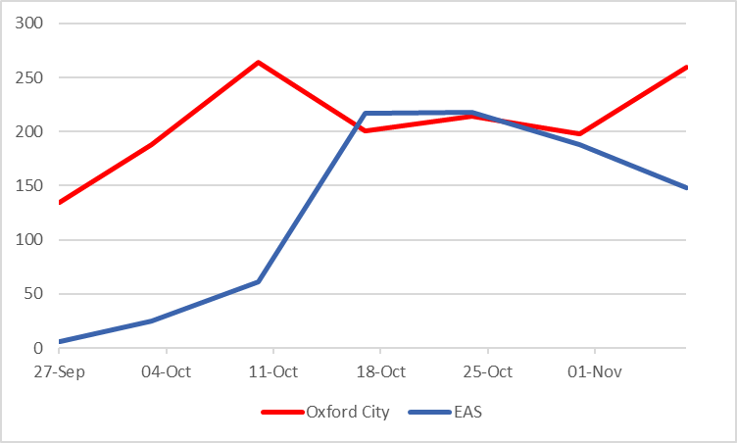
Figure 4: COVID-19 cases reported in Oxford city* and the University (EAS data)
* Oxford data from - https://coronavirus.data.gov.uk/details/cases?areaType=ltla&areaName=Oxford

Lessons from the end of term
When I began drafting this report at the end of Michaelmas term, most undergraduates had just left and EAS was experiencing a very low volume of demand, with only a few (sometimes no) positive tests each day. The situation then began to change. Figure 8 below shows the number of cases detected each day since the end of the student travel window, with EAS cases and NHS Pillar 1 and 2 cases self-reported to EAS indicated in different colours.

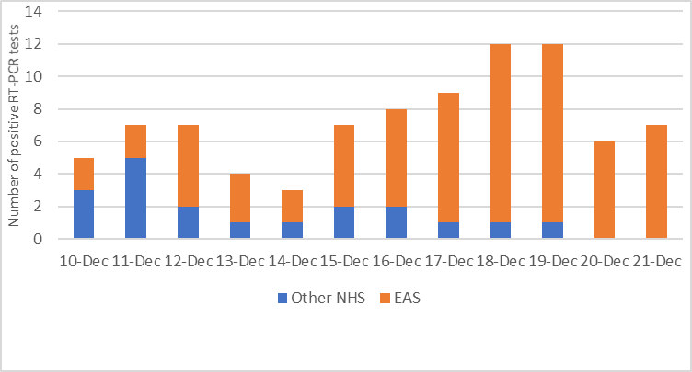
Figure 5: SARS-CoV-2 positive cases detected by RT-PCR since end of student travel window
Of the 72 cases shown here, 31 were staff, 31 postgraduates and 10 undergraduates. This upturn almost certainly reflects the resurgence of the virus in the general population rather than spread within the University, but it emphasises the need for continued vigilance when students and staff return for Hilary term.

