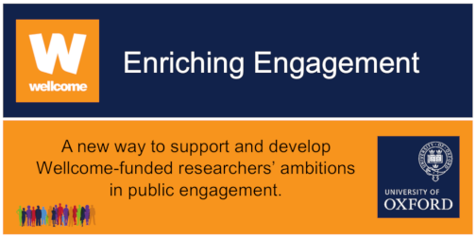
ENRICHING ENGAGEMENT: CASE FOR SUPPORT (≤ 3 pages)

ABOUT YOUR MAIN WELLCOME RESEARCH AWARD/ GRANT FOR WHICH YOU ARE REQUESTING ENRICHING ENGAGEMENT FUNDING (this information is in your Wellcome Grant Letter) [≤ 1 page]

NAME OF PI

TITLE OF MAIN WELLCOME RESEARCH AWARD/ GRANT

TYPE/ NAME OF WELLCOME RESEARCH AWARD/ GRANT (e.g. Fellowship)

START & END DATE

WELLCOME GRANT REFERENCE (13-character reference e.g.111111/Z/11/Z)

BRIEF SUMMARY OF MAIN AWARD & ANY PROGRESS MADE TO DATE

ABOUT YOUR PUBLIC ENGAGEMENT WITH RESEARCH (PER) PROJECT (which must relate directly to your research award/ grant above) [≤1 page]
PER PROJECT TITLE
ARE YOU APPLYING FOR A: | Small Award (£10k - £30k) ☐  Large Award (£50k - £100k) ☐
PROJECT TEAM & THEIR ROLES (including any details of external partners)

n.b. Full details of the project team are entered into your IRAMS application form.

BRIEF DESCRIPTION OF PER PROJECT

FUNDING PANEL  All applicants are invited to discuss their proposals at the funding panels; please indicate which date(s) you can attend. | Tuesday, 1st October 2019 ☐  Tuesday, 8th October 2019 ☐
 | Comments:

PLANNING YOUR PUBLIC ENGAGEMENT WITH RESEARCH (PER) PROJECT (≤ 1 page)
BEFORE | PUBLICS & PARTNERS  Who are your target publics? Why? How will you reach them?  If applicable, who are your partners? Why are you working with them?
 | ENGAGEMENT PURPOSE  Why are you aiming to target these groups? Is it to: |  | Inform & Inspire the Public ☐  Consult & Listen to Public Views ☐  Partner & Collaborate with the Public ☐
DURING | PLANNING  What will you do? When? What will you need? What will you make happen?  [Full costings are entered into your IRAMS application form]
EXPERIENCES
What will the public see, do and gain?

What will researchers see, do and gain?

AFTER | CHANGE/ BENEFITS (OUTCOMES)  What difference will your PER project make? | For the Public
 |  | For the Research; for Researchers
 |  | Other outcomes (e.g. for Partners)
 | ADDITIONAL COMMENTS IN SUPPORT OF YOUR APPLICATION (optional)

CREDIT: This Case for Support template is inspired by a Public Engagement Planning Template developed by FLOW Associates www.flowassociates.com

