Geography Admissions Test Sample Question – PART TWO

Part Two is designed to test your ability to understand and interpret data as part of the process of problem solving. Data interpretation is recognized as one of the key skills for success on the geography degree at Oxford, particularly for the physical geography components of the course.

Sample Question
The diagram below shows the average vehicle speeds during the weekday morning peak (7am-10am) on local ‘A’ roads in England. School holiday periods and the month of August are not included in this diagram. Study the diagram and write a short interpretive essay, covering the following issues:
- A description and explanation of the patterns shown on the graph, including shorter-term and longer-term trends
- Any wider trends that may be reflected by the vehicle speeds data
- How the pattern might look in different regions of England, or on a different type of road.
- How the patterns shown in the graph might change in the future.

Average vehicle speeds during the weekday morning peak (7am to 10am) on local ‘A’ roads in England.

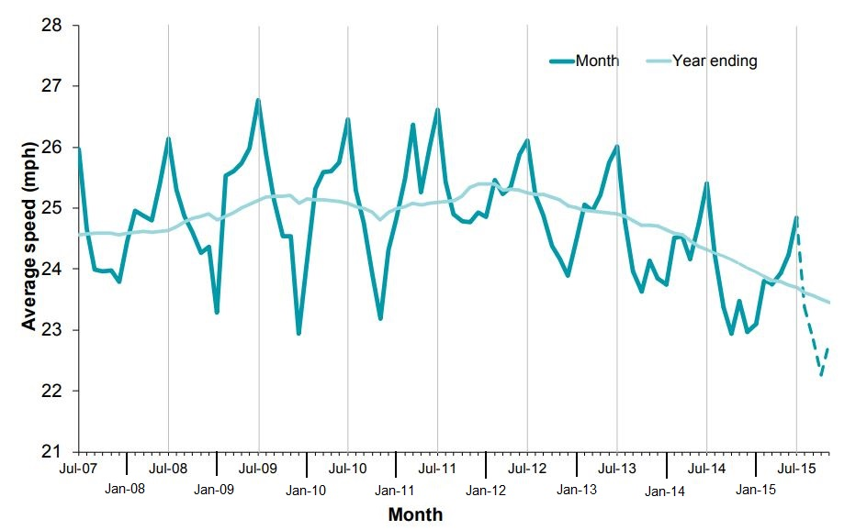

Source: Department for Transport (2016) ‘Congestion on local ‘A’ roads’, England: October to December 2015

Answers to the question could include the following comments:

The diagram shows the average speed of vehicles on ‘A’ roads in England between July 2007 and July 2015. It includes both data by month (dark blue line) and smoothed data (light blue line). A prominent pattern in the data is the annual cycle. Average vehicle speeds are highest during the summer months, with peak speeds in July of between 25-27 mph, and slowest during winter, with the lowest speeds in December and January of 23-25 mph.

This pattern is likely to be related to the differences in weather between the winter and the summer. In the UK there tends to be a greater occurrence of rain, sleet and snow in the winter, which will lead to drivers decreasing their speeds for safety reasons. It could also reflect different numbers of vehicles on the road in different seasons; in the summer, the weather is nicer so more people may walk or cycle, whereas in the winter, more people may drive, leading to higher congestion and lower average speeds.

There are also some general trends over the eight year period shown in the diagram. Between 2007 and 2009 there is a slightly increase in average speeds from around 24.5 mph to 25 mph. Between 2010 and 2012 speeds do not change significantly, before they decrease quite rapidly until 2015, where they fall below 24 mph.

There are also changes in the size of the difference between summer and winter over the eight year period. Between 2008 and 2010 the difference between the summer peak and the winter trough is roughly 3-4 mph. However, from 2011 onwards, the size of this range decreases to roughly 2-2.5 mph. This pattern could reflect unusually severe winter weather in 2009 and 2010, which may have acted to decrease the average vehicle speeds in the winter months more than usual.

The decrease in average speeds from 2012 onwards may reflect wider trends in car ownership and number of vehicles on the road. Since 2008 the number of privately owned vehicles could have increased, resulting in a greater number of cars on the road in general. This will contributed to increased congestion, especially during busy periods like the morning peak rush hour, when people are driving to work and taking children to school. ‘A’ roads do not have as much capacity as larger roads such as dual carriageways and motorways, so may become congested more quickly.

Decreasing average speeds may also reflect an increase in other types of vehicle on the road, such as delivery lorries or vans, which may have increased as people shop online more. In addition these vehicles tend to be slower than cars and other small vehicles, so may contribute to the reduction in average speeds.

In a wider context, deceasing vehicle speeds may reflect changes in levels of local council funding over the eight year period. This might mean that roads aren’t repaired as quickly, resulting in poor road condition, that might result in slower speeds. It may also have contributed to reductions in public transport provision, such as bus routes, which may indirectly contribute to increased cars on the road.

There is likely to be some regional variation across England in the pattern of average vehicle speeds on ‘A’ roads. In densely populated regions like London, the diagram would look similar, but with generally lower speeds, as there are far more cars on the road, as a greater number of people are commuting into London. Conversely, in less densely populated regions outside of major cities, there is likely to be a higher average vehicle speed. However, it may be the case that the general condition of roads is worse in less-urbanised regions, which could decrease the average vehicle speeds. In addition, cities tend to have much better public transport, whereas rural areas may have very little, which would increase the number of privately owned vehicles on the road and thus increase congestion.

In the next few years, it is likely that average vehicle speeds may continue to decrease, as the number of vehicles on the road continues to increase. However, it may be the case that vehicle speeds decrease to such an extent that people choose to use other forms of transport which may be quicker, or preferable to sitting in traffic. It is also possible that levels of car ownership and vehicles on the road may actually decrease in the longer term, as the government tries to phase out cars fuelled by fossil-fuels in favour of more eco-friendly alternatives and better public transport.

