Geography Admissions Test Sample Question B – PART TWO

Part Two is designed to test your ability to understand and interpret data as part of the process of problem solving. Data interpretation is recognized as one of the key skills for success on the geography degree at Oxford, particularly for the physical geography components of the course.

Sample Question B
The graph below shows the number of children born to mothers in selected countries, by level of education of the mother. The level of education of mothers is classified into four categories: no education; primary, secondary; higher. The average level of education is also given for women in each country.

Study the graph and write a short interpretive essay based on the data in the graph.

Your answer should describe and suggest explanations for the patterns shown on the graph, exploring the differences between countries in the number of children born depending on the level of education of the mothers.

Marks will be awarded on the basis of careful reading and interpretation of the data shown in the graph. No specific knowledge is required about the named countries and no credit will be given for external material which is not directly linked to the interpretation of the data presented in the graph.

*********

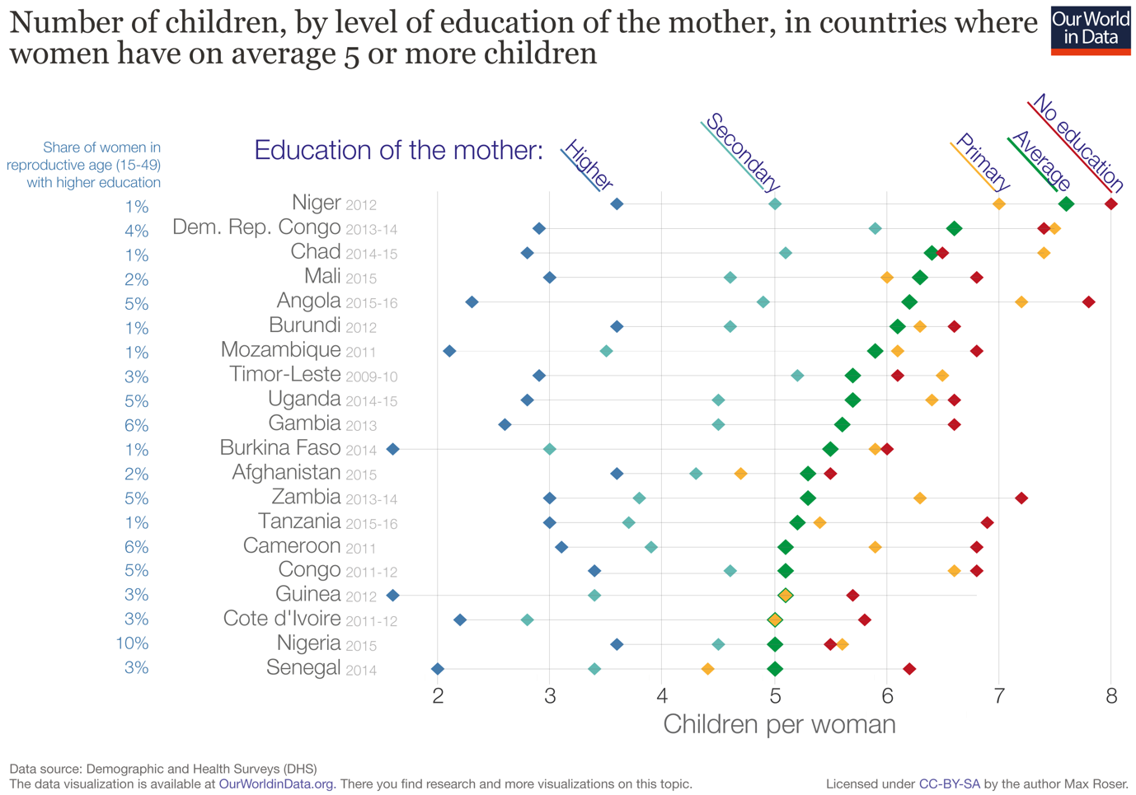

Answers to this question could include the following points:

- For all countries, there is a general correlation between the level of education and the number of children born per woman. For example, for Burkino Faso, women with no education had 6 children on average, whilst woman who had studied in higher education had fewer than 2 children on average. For most countries, the number of children per woman reduces by at least one for each increase in level of education. For example, in Niger, women with no education have 8 children on average, women with primary education have 7 children, and women with secondary education have 5 children.

- Whilst there are variations between countries, for most countries the difference in the number of children born to those with no education and those with primary education is smaller than the difference between those with secondary and those with higher education. For example, in Nigeria, there is very little difference in the number of children born to women with no education compared to those with primary education. However, women in Nigeria with higher education have one fewer child on average than those with only secondary education (3.5 children compared with 4.5 children). In Democratic Republic of the Congo, women with higher education qualifications have 3 fewer children on average than those with secondary education.

- These data may be explained by a variety of factors. Women who have had at least primary level education are more likely to be aware of options for family planning and this awareness is likely to reduce family size. This awareness may, however, only bring about a small decrease in family size unless there are significant economic motivations for reducing the number of children. Women who have had education to secondary level and beyond may be more aware of the employment opportunities available to those who have been educated. They may go into employment outside the home themselves and they may also wish to reduce their family size to ensure that they can pay for education for all of their children. Women who are educated to higher education level will be more likely to gain employment outside of the home and child care costs might discourage these women from having larger families. Employment outside of the home and lifestyle aspirations may explain the significant reduction in number of children per woman educated at higher education level evident in the data for Angola, Chad and Democratic Republic of Congo.

- There are some anomalies in the data set. For example, in Democratic Republic of Congo, Chad and Timor-Leste, women with no education had marginally fewer children per woman than those women educated to primary level. It could be that in these countries women with no education have been more affected by political unrest or extreme poverty and this has affected the rate of infant mortality. It should also be noted that the differences between number of children born to women with no education and primary education are very small for Democratic Republic of Congo and Nigeria and may not be statistically significant.

- Data for Afghanistan and Nigeria is notable because the difference in number of children born to women with no education and women with higher education is less than 2. For Afghanistan, women with higher education have on average 3.5 children, while those with no education have 5.5. This suggests that education is having a more limited effect on family size in these countries. It may be that there is another factor – religious views for example – which is determining family size in these countries.

- When interpreting this data it should be noted that the data refers to different years, so it may not be possible to make direct comparisons between countries. For example, data for Mozambique relates to 2011, while data for Tanzania is from 2015-16. It is possible that there have been recent policy changes in Mozambique which are not reflected in the data set for 2011.

- It should also be noted that for some countries the data set for some categories may be quite small. For example, for Chad 2014-15, only 1% of women aged 15-49 have been educated to higher education level. The graph does not tell us how many women are included in this category in Chad, but if the numbers are low we need to use the data (3 children born per woman) with caution. The data are averages and in a small data set the average could be influenced by outliers.

Examples of detail for which candidates would not be given extra credit in answers to this question would include the following:

- Knowledge of the political or economic situation in any of the countries in the graph
- Knowledge of specific education or family planning policies in these countries or from the UN or other international organisations
- Reference to any countries or data not included in this graph

